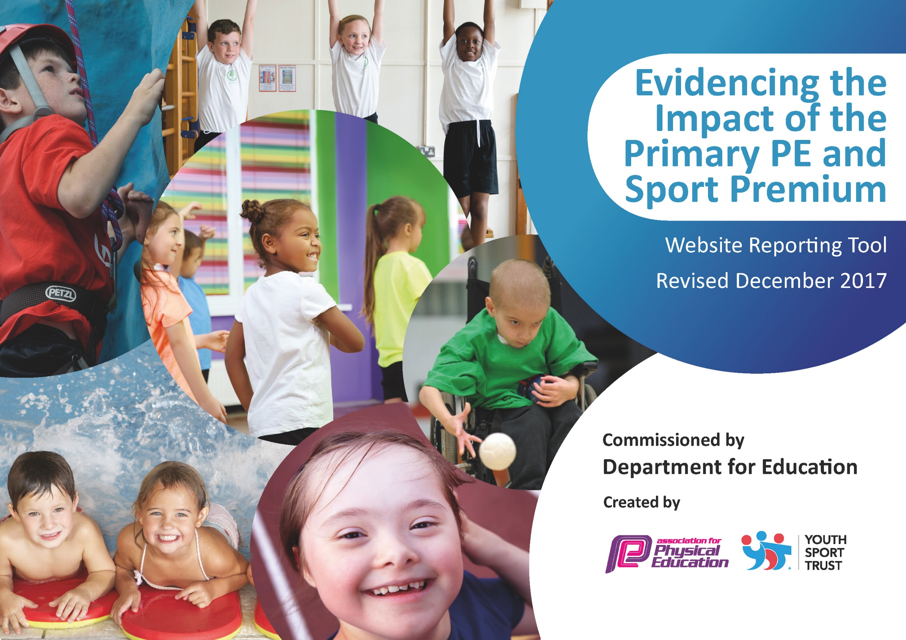

Schools must use the funding to make additional and sustainable improvements to the quality of PE and sport they offer. This means that you should use the Primary PE and Sport Premium to:

- develop or add to the PE and sport activities that your school already offers
- build capacity and capability within the school to ensure that improvements made now will benefit pupils joining the school in future years

Please visit gov.uk for the revised DfE guidance including the 5 key indicators across which schools should demonstrate an improvement. This document will help you to review your provision and to report your spend. DfE encourages schools to use this template as an effective way of meeting the reporting requirements of the Primary PE and Sport Premium.

We recommend you start by reflecting on the impact of current provision and reviewing the previous spend.
Under the Ofsted Schools Inspection Framework, inspectors will assess how effectively leaders use
the Primary PE and Sport Premium and measure its impact on outcomes for pupils, and how effectively governors hold them to account
for this.

Schools are required to publish details of how they spend this funding as well as on the impact it has on pupils’ PE
and sport participation and attainment.
We recommend regularly updating the table and
publishing it on your website as evidence
of your ongoing review into how you are using the money
to secure maximum, sustainable impact. To see an example of how to complete the table please click HERE.

Support for review and reflection - considering the 5 key indicators from DfE, what development needs are a priority for your setting and your students now and why? Use the space below to reflect on previous spend, identify current need and priorities for the future.

Key achievements to date: | Areas for further improvement and baseline evidence of need:
School has achieved School Games Mark for three consecutive years. Bronze, Gold and Silver.  We have high quality P.E. being taught across the school.  Our Staff are trained to confidently deliver the P.E. curriculum.  We offer a breakfast club with a healthy breakfast to enable our children to start the day the right way and be ready to learn.  We offer a variety of after school clubs. (These clubs included Fencing and Golf) at a reduced rate to encourage greater participation and give our children the opportunity to experience a greater range of activities.  We train Y5 and Y6 Pupils to be sports leaders to develop skills which can be used in other areas of their lives.  We offer specialist teaching and young leadership in P.E. and sport within our Academy to continue to raise the profile of sport and in particular, competitive sport within our school's MAC.  We subsidised Cycle training so our children would be safe on the road.  We provided Sports Week where we invited experts in to inspire our children and develop their passion for sport. | This year we intend to continue to embed our good current practice. We will continue to employ two qualified P.E. and sports coaches.  We will also continue to subsidise equipment, transport to and from sporting fixtures for our teams, and school clubs (before school clubs, lunch time and after school clubs) and all children including children with Pupil Premium entitlement, educational difficulties and additional needs.  Develop the outdoor area to promote greater opportunities for all pupils to be physically active during break and lunchtimes.  Implement strategies to increase opportunities for pupils to be physically active during the school day including lessons outside of PE  Creation Games Committee to raise the profile of PE, physical activity and school sport.  Continue to develop opportunities for all pupils to participate in competitive sport  This year we will also use some of the funding in healthy eating, competitive sport (sports competitions, extracurricular clubs and festivals.) and to increase pupils’ participation in sport. We aim to deliver a wider range of activities to encourage a greater participation and develop self -belief and have an 'have a go' attitude in the children.  We want to invest in our children by training them to be leaders in sport.  Offer a variety of Nurture groups through PE.  .

Meeting national curriculum requirements for swimming and water safety | Please complete all of the below*:
What percentage of your current Year 6 cohort swim competently, confidently and proficiently over a distance of at least 25 metres? | 86%
What percentage of your current Year 6 cohort use a range of strokes effectively [for example, front crawl, backstroke and breaststroke]? | 86%
What percentage of your current Year 6 cohort perform safe self-rescue in different water-based situations? | 62%
Schools can choose to use the Primary PE and Sport Premium to provide additional provision for swimming but this must be for activity over and above the national curriculum requirements. Have you used it in this way? | No
*Schools may wish to provide this information in April, just before the publication deadline.

Action Plan and Budget Tracking
Capture your intended annual spend against the 5 key indicators. Clarify the success criteria and evidence of impact that you intend to measure to evaluate for students today and for the future.

Academic Year: 2018/19 | Total fund allocated: £ | Date Updated:
Key indicator 1: The engagement of all pupils in regular physical activity – Chief Medical Officer guidelines recommend that primary school children undertake at least 30 minutes of physical activity a day in school
School focus with clarity on intended impact on pupils: | Actions to achieve: | Funding allocated: | Evidence and impact: | Sustainability and suggested next steps:
Implement strategies to increase opportunities for pupils to be physically active during the school day.We offer 2hours of P.E. per week  For all children.  Offer a variety of Nurture groups through PE  Develop the outdoor area to promote greater opportunities for all pupils to be physically active during break and lunchtimes ay including lessons outside of PE | A Variety of afterschool clubs where children can take part in various sports to increase interest and take up new hobbies. PE is timetables so that every child has 2 hours of PE per week.  We have enrichment groups running for the child where they also take part in different activates that they normal can’t do at school.  We have got different activities and sports running at both break and lunchtimes which children have a choice on what they would like to do on that lunchtime or break time. This gives them the options to play different sports. | £500 equipment  Cost for NURTURE GROUPS THROUGH pe £2000  Other resources to support physical activities outside PE lessons £4000 | We have a variety of afterschool clubs which all focus on different sports and that helps us use the children for different school teams and competitions. Children experience a range of sport throughout the year.  This sessions run every week on the allocated days. This has improved children’s physical skills and wellbeing.  The peer mentors program has helped children instruct and deliver activates. Also the sports activates s have engaged children during break and lunch time. Increased levels of physical activity at break and lunchtimes An improvement in behaviour at lunchtimes and a reduction in the number of incidents reported | To keep the afterschool club running and look to enter a team within that sports and suggest to start a league that have regular fixtures. Continue to develop program where children are active in all lessons  To keep the groups running and progressively give them external links to clubs that run those enrichment programs.  To maintain the peer mentors and give them CPD with new games and ideas to keep the activates fresh for the children. Add more roles to give it a wider spread on the school.
Key indicator 2: The profile of PE and sport being raised across the school as a tool for whole school improvement
School focus with clarity on intended impact on pupils: | Actions to achieve: | Funding allocated: | Evidence and impact: | Sustainability and suggested next steps:
Creation of Sports Committee to raise the profile of PE, physical activity and school sport  We have started an Olympic legacy program with afterschool having Volleyball, Dodgeball, Basketball, Boccia, Ultimate Frisbee. | We have our sports leaders who help with organizing the school games competitions in house and externally And make suggestions how we can improve pe and sport in school  Courses are provided to give Staff CPD across new sports and programs running to give the children the best facility. | £500  £500 | The children have an investment in the PE /sport provided at school. Promotion of the range of activities school provides. Pupils to have greater ownership in the development of PE, physical activity and school sport  This gives children a different look at sports that are out there. | To give them the lead and create new tournaments. Organize an annual meeting for frequently.  To keep the courses going and make sure if there is any re fresher’s that to book on to keep the CPD there. To get in house competitions running in those sports.

Key indicator 3: Increased confidence, knowledge and skills of all staff in teaching PE and sport |  |  |  |  |  | Percentage of total allocation:
 |  |  |  |  |  | %
School focus with clarity on intended  impact on pupils: | Actions to achieve: | Funding  allocated: |  |  | Evidence and impact: | Sustainability and suggested  next steps:
Ongoing professional development programme for teaching staff to improve the quality of PE taught across the school  Improve the knowledge of swimming for staff. All staff have swimming CPD to ensure that with skills to teach swimming. | Ongoing support programme in place between external provider and school – team teaching etc.  Encourage staff to use other strategies to promote greater physical activity during other lessons  Year 3 and 4 Teachers to receive swimming training. | Cost of support programme with external provider –  And new equipment  £7000  £400 |  |  | Increased teacher confidence, knowledge and understanding of specific skills to deliver PE lessons of higher quality.  Increased teacher confidence, knowledge and understanding of specific skills to deliver swimming lessons of higher quality. | Model of development programme allows staff to take the lead under the direction and support from sport educators. Highly qualified staff to teach P.E.
Key indicator 4: Broader experience of a range of sports and activities offered to all pupils
School focus with clarity on intended  impact on pupils: | Actions to achieve: | Funding  allocated: |  |  | Evidence and impact: | Sustainability and suggested  next steps:
Continue to develop the opportunities for all pupils to participate in activities (before school, at lunchtimes and after school)  Continue to offer sports club during all holidays at a reduced rate to encourage physical activities | Identify and engage community clubs and delivery partners.  • Increase the number of opportunities available to pupils to participate in extra-curricular activities (across KS1 and 2)  School provides a calendar of sport to be offered throughout the year. | See above for funding allocation.  £1000 |  |  | Children are engaged in sport before/lunch time and after school. Increased opportunities for pupils to participate in school sport both in house and within the wider community  E.g. Irish dancing, football, swimming.  Increased levels of physical activity at break and lunchtimes an improvement in behaviour at lunchtimes and a reduction in the number of incidents reported  Increased opportunities for pupils to participate in school sport in house. | Intra school competitions to continue through and Inter school competitions through School Games programme  To continue to offer holiday club during all school holidays
Key indicator 5: Increased participation in competitive sport
School focus with clarity on intended  impact on pupils: | Actions to achieve: | Funding  allocated: |  |  | Evidence and impact: | Sustainability and suggested  next steps:
Continue to develop opportunities for all pupils to participate in competitive sport | Liaise with School Games Organiser to register for competitions throughout the year  Promote opportunities for competitive sport through PE lessons using the School House System. Preparing pupils to participate in School Games and other Competitions throughout the year with support from the PE Coordinator. | £1000 for transport and entrance fees |  |  | Increased opportunities for pupils to participate in school sport | Intra school competitions to continue through  Inter school competitions through School Games programme and opportunities
Key indicator 6: Meeting national curriculum requirements and providing additional provision for swimming and water safety from the premium. (2 national curriculum swimming + 2 Primary Premium spend on swimming)
Approach (clarity on intended impact on pupils) | Actions to achieve: | Funding  allocated: |  |  | Evidence and impact: | Sustainability and suggested  next steps:
1(Nat. Curriculum) The pupils are taught swimming during Years 3 and 4. The swimming teacher provides an assessment on whether the pupils have achieved the expected standard. | Work with local pool provider to identify pupils who will require additional support in order to achieve standard.  Organise transport and staff | £1200 |  |  | Pupils meet NC curriculum standard for swimming. | Identify children who have not achieved NC swimming expectations and provide top up sessions to ensure they meet the required standard by y6.

